Media Note

21 Sept 2020

The implication of a “K-Shaped” US Market Recovery – and the winners and losers

Michael LaBella, Head of Investment Strategy at QS Investors
The S&P 500 Index reached a historic high on February 19th of this year, only to break that record less than six months later. On its face this sounds reasonable, however when considering the unprecedented nature of the events that transpired in-between, this is downright shocking. Over this six-month period the S&P 500 realized its swiftest decline in history, contracting over 30% in less than 22 trading days, putting an end to the 11-year bull market, as 9.5 years of job gains were wiped away in less than a month. The US government passed a $2 trillion relief package, the largest stimulus in history as the Fed slashed interest rates near zero. In the meantime, the US economy shrank by an annualized 32.9% quarter-over-quarter on an annualized basis, the largest ever recorded contraction.
While all these cataclysms occurred, the S&P 500 index continued to climb from its March 23rd lows. There was much discussion on whether this rebound would be V-shaped (a quick decline followed by an even faster recovery), U-shaped (taking months, if not years to fully recover), or even W-shaped (whereby the economy begins to recover rapidly but then falls into a second period of decline).
When we categorize the various components of the index, what the market recovery to date has really ended up looking like is a K, a bifurcated recovery with two lines diverging on a chart.
What are those two lines you may ask? It could be anything from the NASDAQ vs the S&P 500 Index, US Large Cap vs US Small Cap, or Growth vs Value.

Exhibit 1: Nasdaq vs. S&P 500
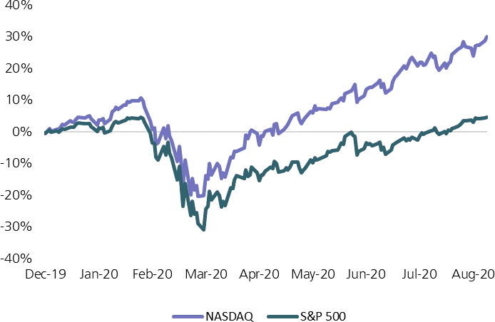
Source: Bloomberg, cumulative daily returns. Indices as of August 18, 2020.

Winners and losers at this point are still defined by those that did well during the pandemic - internet retailers, tech-enabled social media and remote working platforms - versus those which had to virtually cease operations as 95% of Americans were under stay at home orders - restaurants, resorts/hotels, airlines and movie theatres.
While 300 stocks in the S&P 500 still lie in negative territory, the top five stocks by size (Apple, Microsoft, Amazon, Facebook and Alphabet) are up approximately 40% on average for the year. However, these 300 companies make up only 37% of the S&P 500 Index by market cap, whereas the top five companies represent 23% of the Index. Big Tech has only gotten bigger.
Looked at in a slightly different way, without three companies - Amazon, Apple, and Microsoft - the return on the S&P 500 including dividend payments would have been -4.1% this year through the end of July. Instead, the S&P 500 returned 2.4%. Earnings and sales for the broader market have fallen over the last six months and as a result the market now looks even more expensive than it did before.
This begs investors to question where to put money next? We believe now may be the time to invest in a comprehensive recovery, the second leg of the ‘K’.
Value-oriented companies with strong sustainable dividend profiles now trade at an extreme valuation versus technology and tech-enabled consumer stocks. Not only do these stocks offer a significant source of income, but they provide exposure to the broader US recovery at an attractive price.
In the US, value stocks have, on average, outperformed by 730 basis points in the 12 months following a trough in the business cycle (Source: NBER, Ken French. Data from 1927-present).
-ends-

For all media queries please contact:
Simrita Virk at Shed Connect
simrita.virk@shedconnect.com

